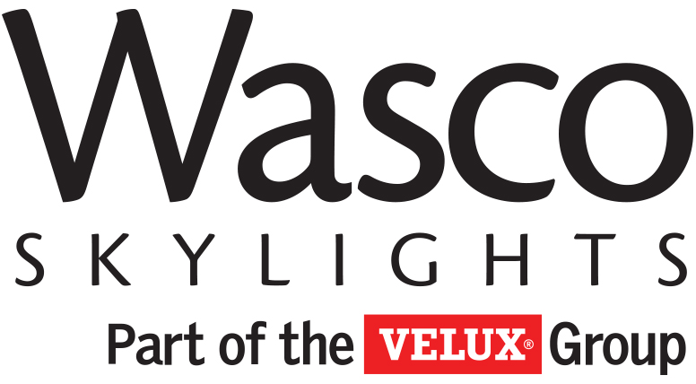

SECTION 08 45 00
M-SERIES MONOLITHIC POLYCARBONATE GLAZED CANOPY

PART 1 - GENERAL

1.1 SUMMARY

- This Section includes the following:
  - Pre-engineered monolithic glazed canopy system.

- Related Sections may include but are not limited to the following:
  - Division 5 Section “Structural Steel” for metal framing.

1.2 PERFORMANCE REQUIREMENTS

- General: Provide canopy capable of withstanding loads as defined by the local codes having jurisdiction where units are to be installed without failure.
- Deflection of the entire length of aluminum framing members in direction normal to glazing plane is limited to 1/120 of clear span.
- Structural Loads: Provide canopy system, including anchorage, capable of withstanding the effects of the following design loads when supporting full dead loads:
  - Canopy Loads
    - Snow Loads: __________________ (Input job specific requirements)
    - Wind Loads: __________________ (Input job specific requirements)

1.3 SUBMITTALS

- Shop Drawings: Include plans, details, and attachments to other work.
- Samples for Initial Selection: Manufacturer’s color charts showing the full range of colors available for factory-finished aluminum.
- Samples for Verification: Finish and Glazing samples if required are to be provided.

1.4 QUALITY ASSURANCE

- Installer Qualifications: An experienced installer who has specialized in installing metal-framed canopies similar to those indicated for this Project.
- Professional Engineer Qualifications: A professional engineer who is experienced in providing engineering services of the kind indicated.

1.5 PROJECT CONDITIONS

- Field Measurements: Where canopy framing is indicated to fit to other construction, verify dimensions of other construction by field measurements before fabrication and indicate measurements on Shop Drawings. Coordinate fabrication schedule with construction progress to avoid delaying the Work.
  - Established Dimensions: Where field measurements cannot be made without delaying the work, establish dimensions and proceed with fabricating canopy without field measurements. Coordinate construction to ensure that actual dimensions correspond to established dimensions.

1.6 WARRANTY

- Warranty: Written warranty, executed by manufacturer agreeing to repair or replace components of the canopy that fail in materials or workmanship within specified warranty period. Failures include, but are not limited to, the following:
  - Deterioration of metals, metal finishes, and other materials beyond normal weathering.
  - Warranty Period: 10 years from date of shipment from the manufacturer.
- Plastic Warranty: Provide written warranty signed by manufacturer agreeing to repair or replace work that has or develops defects in the plastic. “Defects” is defined as abnormal aging or deterioration.
  - Warranty Period for polycarbonate: 10 years from date of shipment from the manufacturer.
- Finish Warranty: Provide written warranty signed by manufacturer agreeing to repair or replace work with finish defects. “Defects” is defined as peeling, chipping, chalking, fading, abnormal aging or deterioration, and failure to perform as required.
(Edit as Required)
- Warranty Period for Anodized Finish: 1 year from date of shipment from the manufacturer.
- Warranty Period for Powder Coat Finish: 5 years from date of shipment from the manufacturer.
- Warranty Period for Kynar 500 Finish: 5 years from date of shipment from the manufacturer. (10 and 20 years available if specified).

PART 2 - PRODUCTS

2.1 MANUFACTURERS

- Basis of Design: Provide M-Series products by Wasco Skylights part of the Velux Group, Wells, ME (800-933-0593).
- Substitutions: Manufacturers shall not be considered without prior approval in writing no later than ten (10) calendar days prior to bid. Substitute manufacturers must have been in the custom skylight business for not less than a period of 15 years and must submit to the Architect the following:
  - Proof of financial capability.
  - Complete details of proposed canopy.
  - Complete specifications for Architect’s review.

2.2 FRAMING MATERIALS

- Framing Members: Extruded aluminum alloy 6063-T5 or T6, ASTM B 221 (ASTM B 221M) with minimum effective thickness of 0.109 inches. Provide integral condensation gutter system.
- Recommended minimum pitch:
  - ½” in 12”
- Exterior Pressure Caps: Extruded aluminum alloy 6063-T5 or T6, ASTM B 221 (ASTM B 221M) with minimum effective thickness of 0.090 inches.
- Fasteners and Accessories: Manufacturer’s standard corrosion-resistant, non-staining, non-bleeding fasteners and accessories; compatible with adjacent materials.
  - Aluminum Retaining Cap Fasteners and Framing Members Fasteners: ASTM A 193/A 193M, Series 300 stainless-steel screws; type as recommended by manufacturer.
  - Connections to Supporting Structure: Series 300 Stainless Steel.
- Framing-System Sealants: Single-component, non-sag, high performance, non-priming, gun-grade elastomeric polyurethane sealant furnished by canopy manufacturer.
  - Sealant complies with ASTM C920, Type S, Grade NS, Class 25, Use T, NT, M, A, G, and O. Canadian Specification CAN/CGSB-19.13-M87, Classification MCG-2-25-A-N.
  - Sealant conforms to USDA approval standards.

2.3 GLAZING MATERIALS

- Provide monolithic polycarbonate sheet fabricated from an approved polycarbonate glazing (light transmitting) material identical to that tested with a CC1 fire rating.
  - Self-Ignition Temperature: 650 deg F (343 deg C) or greater when tested per ASTM D 1929 on plastic sheets in the thickness intended for use.
  - Smoke developed index not greater than 450 where tested in the manner intended for use in accordance with ASTM E 84 or UL 723, or a maximum average smoke density rating not greater than 75 where tested in the thickness intended for use in accordance with ASTM D 2843.
  - Relative- Burning Characteristics: Burning extent of 1 inch (25mm) or less where tested at a nominal thickness of 0.060 inch (1.5mm), or in the thickness intended for use in accordance with ASTM D 635.
- Glazing Gaskets: Manufacturer’s proprietary pressure-glazing gaskets of elastomer type and hardness selected by canopy manufacturer to comply with requirements. Glazing gaskets to be extruded Thermoplastic Elastomer by the canopy manufacturer.
- Glazing Weatherseal Sealant: Neutral-curing silicone sealant recommended by canopy and sealant manufacturers for this use.
    - Sealant is capable of withstanding 50 percent movement in both extension and compression (total of 100 percent movement) when tested for adhesion and cohesion under maximum cyclic movement according to ASTM C 719.
    - Sealant complies with ASTM C 920 for Type S, Grade NS, Class 25, Uses NT, G, A, and O, as applicable to substrates including other sealants with which it comes in contact.
    - Color: Black
- Flashing Sealant: Single-component, non-sag, high performance, non-priming, gun-grade elastomeric polyurethane furnished by canopy manufacturer.
  - Sealant complies with ASTM C920, Type S, Grade NS, Class 25, Use T, NT, M, A, G, and O. Canadian Specification CAN/CGSB-19.13-M87, Classification MCG-2-25-A-N.
  - Sealant conforms to USDA approval standards.
- Glass fiber reinforced thermoset resin sheets are not acceptable.
- Color: Manufacturer’s standard – Clear or White (Contact manufacturer for other color options).

2.5 ALUMINUM FINISHES (Edit as Required)

- General: Comply with NAAMM “Metal Finishes Manual” recommendations for application and designations of finishes.
- Finish designations prefixed by AA conform to the system for designations of aluminum finishes established by the Aluminum Association.
  - Mill Finish: Manufacturer’s standard mill finish.
  - Clear-Anodized Finish, Class I: AA-C22A41 complying with AAMA 611.
  - Clear-Anodized Finish, Class II: AA-C22A31 complying with AAMA 611.
  - Color –Anodized Finish Class I: AA-C22A42/A44 complying with AAMA 611. Color:______________
  - Kynar Fluoropolymer Two-Coat System: (70% PVDF) complying with AAMA 2605. Color:______________ (3coat and 4 coat available)
  - Powder Coat High-Performance Architectural Coating: comply with AAMA 2604. Color:______________

PART 3 - EXECUTION

3.1 EXAMINATION

- Examine substrates and conditions, with Installer present, for compliance with requirements for installation tolerances and other conditions affecting canopy performance.
  - Proceed with installation only after unsatisfactory conditions have been corrected.

3.2 PREPARATION

- Metal Protection: As follows:
  - Where aluminum will contact dissimilar metals, protect against galvanic action by painting contact surfaces with primer or by applying sealant or tape recommended by manufacturer for this purpose.
  - Where aluminum will contact concrete or masonry, protect against corrosion by painting contact surfaces with bituminous paint.
  - Where aluminum will contact pressure-treated wood, separate dissimilar materials by methods recommended by manufacturer.

3.3 INSTALLATION

- General: Comply with manufacturer’s written instructions for protecting, handling, and installing canopy components.

- Following manufacturer’s installations instructions and job specific drawings to ensure proper installation.

- Coordinate with installation of other substrates to receive canopy units.

3.4 CLEANING
        - Clean exposed metal and glazing surfaces according to manufacturer’s instructions during installation. Touch up damaged metal coatings.
        - Final cleaning by others.

END OF SECTION

